



Essay / Assignment Title: Machine Learning Meets Term Life Insurance: Targeting High-Value Customers

Programme title:

Name:

Year:

CONTENTS

CONTENTS I
LIST OF FIGURES III
LIST OF TABLES IV
INTRODUCTION 1
Overview of HashSysTech Insurance 1
Project Greenlight and Term Life Insurance Targeting 1
1. TASK 1: DATA EXPLORATION AND PREPARATION 2
1.1. Data Exploration 2
1.1.1. Descriptive Statistics 2
1.1.2. Correlation Analysis 4
1.2. Handling Missing Values and Outliers 6
1.2.1. Handling Missing Values 6
1.2.2. Detecting and Handling Outliers 11
1.3. Data Visualization 12
1.3.1. Scatter Plots 12
1.3.2. Histograms 13
1.3.3. Box Plots 13
2. TASK 2: MODEL SELECTION AND TRAINING 15
2.1. Model Selection 15
2.2. Data Splitting 16
2.2.1. Summary of Steps 18
3. TASK 3: MODEL INTERPRETATION AND EVALUATION 19
3.1. Model Interpretation 19
3.1.1. Decision Tree Model Interpretation 19
3.1.2. Logistic Regression Interpretation 22
3.1.3. Random Forest Interpretation 24
3.2. Model Evaluation 24
4. CONCLUDING REMARKS 26
4.1. Summary of Findings 26
4.2. Business Implications for HashSysTech Insurance 26
BIBLIOGRAPHY 28
APPENDIX 30
Code Implementation 30

LIST OF FIGURES

Figure 1: Python code for calculating descriptive statistics 3
Figure 2: Python code for analyzing frequencies of categorical features 4
Figure 3: Python code to compute the correlation matrix 5
Figure 4: Correlation Matrix of Numerical Features 5
Figure 5: Python code to identify missing values 6
Figure 6: Python Code: Removing Rows with Missing Data 7
Figure 7: Python Code: Mean Imputation for Numerical Features 8
Figure 8: Python Code: Median Imputation for Numerical Features 8
Figure 9: Python Code: Mode Imputation for Categorical Features 8
Figure 10: Python Code: K-Nearest Neighbors Imputation 9
Figure 11: Python Code: MICE Imputation for Missing Values 10
Figure 12: Python Code: Dropping Columns with Excessive Missing Data 10
Figure 14: Python code to detect outliers using Z-scores 11
Figure 15: Python Code: capping outliers using Winsorization 12
Figure 16: Scatter Plot: Age vs. Call Duration with Conversion Status 13
Figure 17: Python code for generating histograms 14
Figure 18: Box Plot: Duration Distribution by Conversion Status 15
Figure 19: Jupyter Notebook Code: Model Initialization 17
Figure 20: Python Code: Splitting the Dataset into Training and Testing Sets 18
Figure 21: Python Code: Encoding Categorical Columns Using LabelEncoder 19
Figure 22: Python Code: Standardizing the Dataset 20
Figure 23: Python Code: Training and Evaluating the Decision Tree Model 21
Figure 24: Python Code: Feature Importance from Decision Tree 23

LIST OF TABLES

Table 1: Feature Importance from Decision Tree Model 21
Table 2: Feature Importance in Logistic Regression Model 23
Table 3: Model Evaluation of Decision Tree, Logistic Regression and Random Forest Models 24

Statement of compliance with academic ethics and the avoidance of plagiarism

I honestly declare that this dissertation is entirely my own work and none of its part has been copied from printed or electronic sources, translated from foreign sources and reproduced from essays of other researchers or students. Wherever I have been based on ideas or other people texts I clearly declare it through the good use of references following academic ethics.
(In the case that is proved that part of the essay does not constitute an original work, but a copy of an already published essay or from another source, the student will be expelled permanently from the postgraduate program).

Name and Surname (Capital letters):

.......................................................................................................................................

Date: ........................./........../.........

INTRODUCTION

Overview of HashSysTech Insurance
HashSysTech Insurance is a forward-looking and growing insurance company specializing in the provision of insurance services, especially term life assurance. In the years past, this company has used various methods to market its products to various potential customers, and out of all these marketing strategies, the company has dramatically relied on telemarketing as one of the most effective means through which it can get its customers to buy its products. However, as competition increases and the cost of doing business increases, HashSysTech is faced with the future problem of achieving efficient resource utilization and consistently generating high returns from these campaigns. To this effect, the company is on the lookout for tools that will enable it to obtain relevant information that can be used for targeting prospects with high levels of potential.

Project Greenlight and Term Life Insurance Targeting
To counter the effects of rising costs and the need to be efficient, HashSysTech embarked on a new project called Project Greenlight, which aimed at coming up with improved telemarketing techniques so as to pinpoint who among the population is likely to accept the offered term life insurance. The aim here is to lessen the impact of marketing and, at the same time, ensure that the campaigns are much more relevant, cheaper, and effective. By applying this project, HashSysTech shall reduce the chances of wastage of resources by only concentrating on those potential clients who are most likely to create a sale. The solution lies in having a robust and wealthy machine learning model that would help analyze parts of customer data and the possible following conversions, as well as other vital strategic decisions of the subsequent campaigns that need to be created. This assignment focuses on the creation of such a model to help the company improve its telemarketing business by increasing the effectiveness of its telemarketing calls made to potential clients.

TASK 1: DATA EXPLORATION AND PREPARATION

Data Exploration
Data exploration is the first step in the data analysis process (Lester, Cho, and Lochmiller, 2020). It allows one to get acquainted with a new set of data, especially its structure, patterns, and key statistics. Data exploration also helps the analyst recognize patterns, correlations, and outliers that may affect the model.
The dataset used for this project is from HashSysTech Insurance Company. The variables used alongside customer characteristics involve the communication aspect and past experiences in telemarketing sales. This step involves summarizing numerical and categorical features and examining them in correlation to the variable that defines whether the customer transitions to term life insurance.

Descriptive Statistics
For numerical features, measures of central tendency in the form of Mean and Median and measures of dispersion in Standard Deviation are conducted (Cai, Zhou, and Pan, 2021). These measures enable one to glimpse how the information is distributed and look for any irregularities in the data.
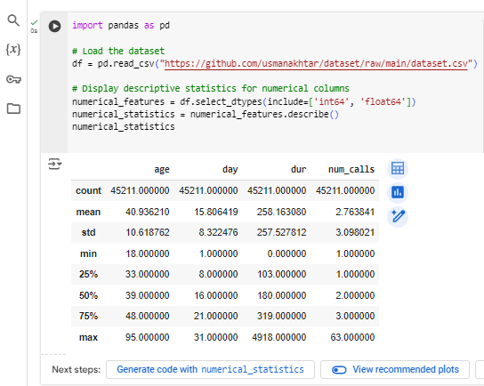
Figure 1: Python code for calculating descriptive statistics
In Figure 1, the code calculates the count, mean, standard deviation, minimum, maximum, and quartile of the numerical features so that Analysts can get a complete picture of how these values are distributed in a dataset.
The frequency distribution of the category is also computed in the case of categorical features to identify the occurrence of the specific category (Hancock, and Khoshgoftaar, 2020). This step makes it easier to identify the common characteristics that define the majority of the customers.
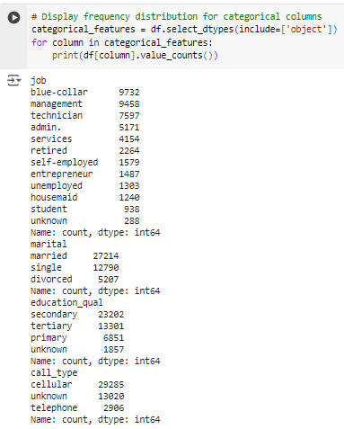
Figure 2: Python code for analyzing frequencies of categorical features
In Figure 2, the code process gives one, an insight into the demographic attributes of these customers, such as age, gender, marital status, and other important classes.

Correlation Analysis
Understanding how different features relate to the conversion is essential to explore their importance. A correlation matrix can be computed to check the degree of relation between each of the numerical variables and the target variable or any other numerical variable. If two exact features are strongly correlated, these features could significantly impact the model.
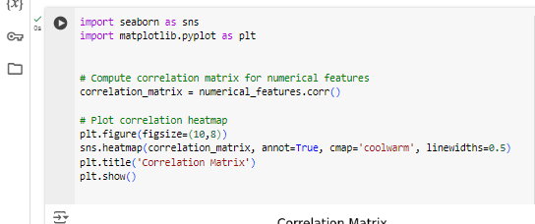
Figure 3: Python code to compute the correlation matrix
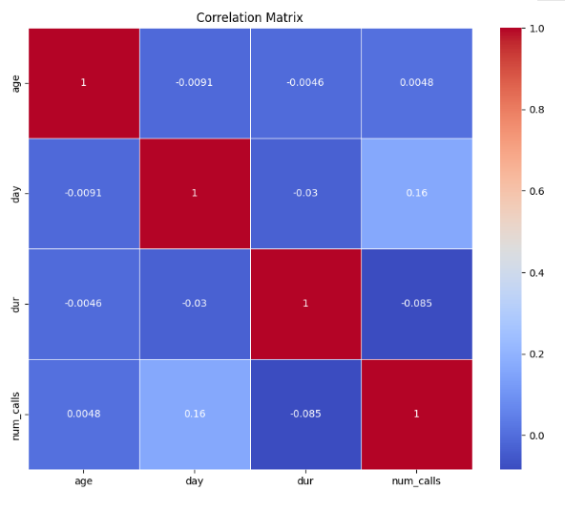
Figure 4: Correlation Matrix of Numerical Features
The heatmap helps determine which numerical features correlate strongly with the conversion variable, which dictates the next model and feature engineering (Lububu, and Kabaso, 2023).

Handling Missing Values and Outliers
Missing data and outliers are essential to handling data preparation as they affect the performance and accuracy of most machine learning algorithms (Joel et al., 2022).

Handling Missing Values
The first step is to check the dataset, to see if any missing values exist. Based on the proportion of missing data and the feature type, different techniques can be applied.
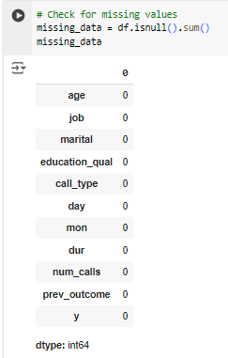
Figure 5: Python code to identify missing values
As seen from Figure 5, this dataset does not have missing values; therefore, no action is required to handle the missing data. This is beneficial because it ensures all features are available and can be used without further pre-processing steps. Thus, it is essential to be aware of the several approaches to handling missing values in a database. Even though no missing values have been observed in the dataset of this particular case study, missing data is a phenomenon that is frequently encountered in actual databases. Inadequate data may bring out biases in the entire study; hence, such data must be handled well to avoid misleading conclusions.
- Listwise Deletion (Removing Rows with Missing Data)
In case of missing data, you can remove the rows that contain missing values.
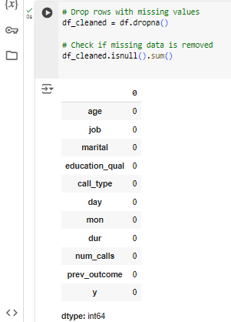
Figure 6: Python Code: Removing Rows with Missing Data
- Imputation Techniques
If deletion is not the best approach, imputation is always an option. Below are some procedures that can be used to input the missing data.
Mean/Median Imputation for Numerical Data
Mean or median imputation is often used for numerical data, especially when the distribution is not highly skewed.

Figure 7: Python Code: Mean Imputation for Numerical Features
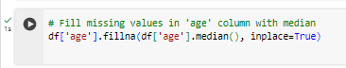
Figure 8: Python Code: Median Imputation for Numerical Features
Mode Imputation for Categorical Data
Categorical variables can be imputed using the most frequent value (mode).
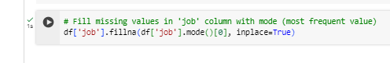
Figure 9: Python Code: Mode Imputation for Categorical Features
- K-Nearest Neighbors (KNN) Imputation
The KNN imputation technique fills in the missing values based on the distance closest to it. This is useful, especially in cases of feature disparities and correlations.
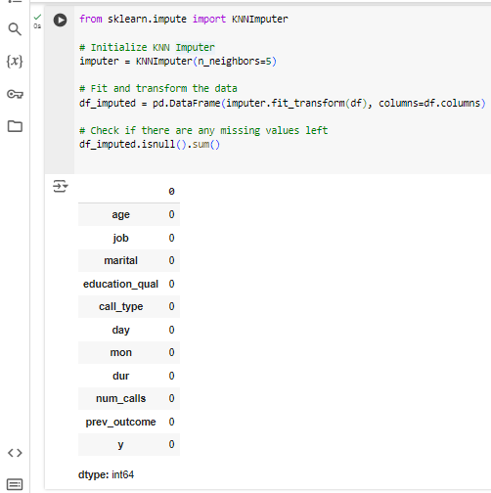
Figure 10: Python Code: K-Nearest Neighbors Imputation

- Multiple Imputation with MICE (Multiple Imputation by Chained Equations)
Multiple Imputation by Chained Equations (MICE) is a more powerful imputation approach that successively estimates missing observations and develops several datasets for the last analysis.
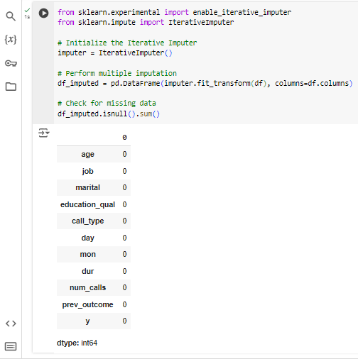
Figure 11: Python Code: MICE Imputation for Missing Values
- Dropping Columns with Too Many Missing Values
Whenever some of the columns contain so many blank values, it is advisable to exclude such variables.

Figure 12: Python Code: Dropping Columns with Excessive Missing Data
It is noteworthy that missing data is critical in data analysis, and depending on the data type, the extent of missing data, and the goal of the analysis, it could be handled by deletion, imputation, or regression (Enders, 2022). These methods are helpful for future projects and are fundamental even in a dataset where they are not a prerequisite in the research process.

Detecting and Handling Outliers
In statistics, outliers are extreme values that can easily be distinguished from other values in the database (Smiti, 2020). They can potentially affect the output of a model, which is why, if present, they have to be identified properly. In numerical features, outliers can be detected by observing the box plots or calculating the values' Z-scores. Data points with a Z-score greater than or equal to 3 can be examples of thresholds for outliers.
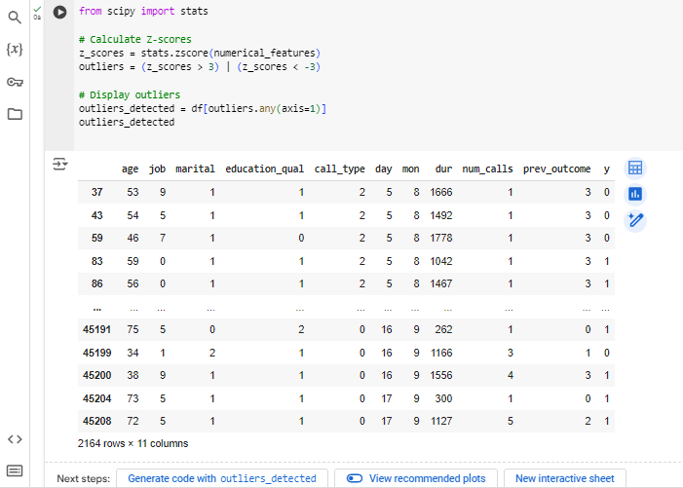
Figure 13: Python code to detect outliers using Z-scores
Once outliers are identified, they can be dealt with by employing techniques such as removing, transforming, or capping by Winsorization.
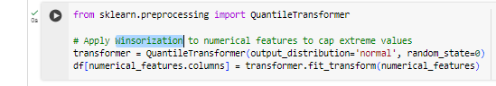
Figure 14: Python Code: capping outliers using Winsorization
This ensures that extreme values do not disproportionately influence the machine learning model.

Data Visualization
For exploratory purposes, graphing the dataset becomes necessary to see the correlation and trends between these features (Javed et al., 2021). This also assists in generating our hypothesis about which features might be significant in terms of term life insurance conversion.

Scatter Plots
Scatter plots can be used to corroborate the impact of two quantitative variables and the target variable.
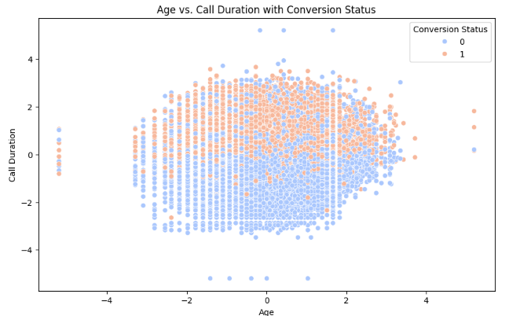
Figure 15: Scatter Plot: Age vs. Call Duration with Conversion Status
As seen in Figure 16, with the help of Age vs call duration plotting , It can aid the investigation of the outcome determine which category is more likely to convert in history so that relevant features can be selected.

Histograms
Histograms are useful for examining the distribution of individual numerical features.
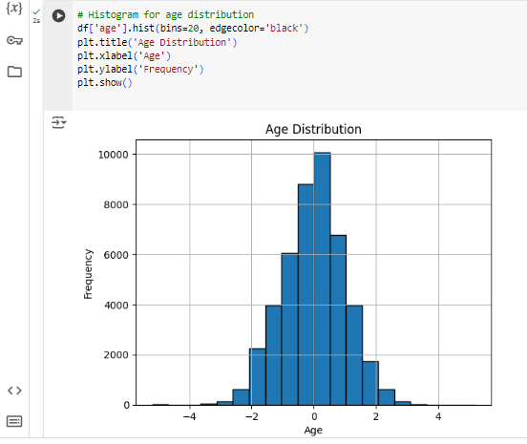
Figure 16: Python code for generating histograms
With the help of a Histogram shown in Figure 17, we can get information on the customers' age structure, and one can trace this to conversion patterns.

Box Plots
Box plots are ideal for determining the presence of outliers and data distribution concerning the categories.
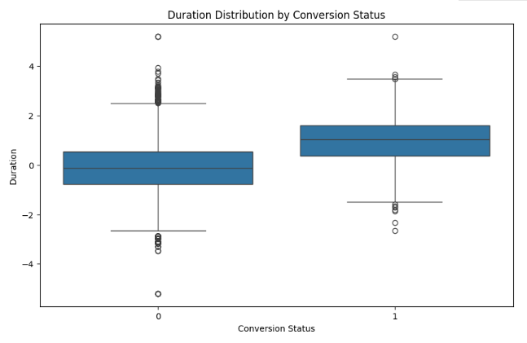
Figure 17: Box Plot: Duration Distribution by Conversion Status
The box plot in Figure 18, displays the distribution of the customers who converted to the target and the customers who did not, allowing the viewer to quickly and easily pinpoint any distinctions. These visualizations, along with the summary statistics obtained in the previous step, allow for forming hypotheses for the tasks, which will be developed in the next step of the analysis.
To sum up, Task 1 provides the ground for constructing the strong machine learning model because it helps to ensure that the information is clear and clean and, therefore, clearly visualized. This is important in order to pave the way for the next steps, which include model selection, training, and the evaluation of the ideal model.

TASK 2: MODEL SELECTION AND TRAINING

Model Selection
Model selection is essential in building a model solution because it defines the best algorithm for the dataset and the problem to be solved with the dataset (Injadat et al., 2020). In this task, therefore, the aim is on the classification problem, which entails the variable of interest, y, being equal to 1 if a customer has converted or 0 if they haven’t. Several classification models are used, and among them, an optimal is chosen, which includes the aspect of the complexity of the model, the time required for training, accuracy attained, and the interpretability of the model.
- Step 1: Understanding the Problem. The aim of this task is to estimate whether a particular customer tends to convert, considering several features such as age, job, education, etc., and call the title back. Since it is a binary classification problem, a model is needed to help classify the problem into two results.
- Step 2: Evaluating Suitable Models For binary classification problems, the following models are commonly evaluated:
- Logistic Regression: This basic model is used to compare with other models to check performances. This method is applicable only if the relation between input features and target is linear.
- Decision Tree Classifier: An over-parameterized model that is interpretable and can fit decision surfaces of a high degree of complexity. Nevertheless, it is susceptible to overfitting.
- Random Forest Classifier: A combination of decision trees that can reduce over-learning and produce better products.
After the models have been selected, they are assessed using cross-validation, in which the dataset is partitioned into the training and validation datasets.
- Step 3: Selecting the Model. The Decision Tree Classifier is initially used in this scenario due to its interpretability and its ability to handle both nominal and quantitative variables. Moreover, two more models, random Forest and Logistic Regression models will also be implemented.
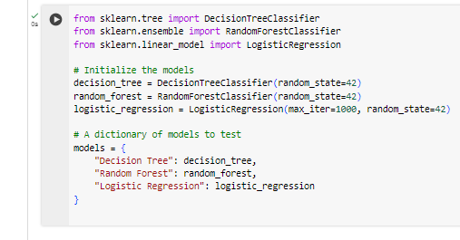
Figure 18: Jupyter Notebook Code: Model Initialization

Data Splitting
To implement the models, the data is first divided into training data and testing data (Nguyen et al., 2021). Training data is employed for training purposes, and testing data is used to test the model's performance.
- Step 1: Division of Dataset. The information is divided into training and testing independent datasets where the former is 80% while the latter is 20%. Some of the most common functions used for this purpose are the train_test_split from the Scikit-learn.
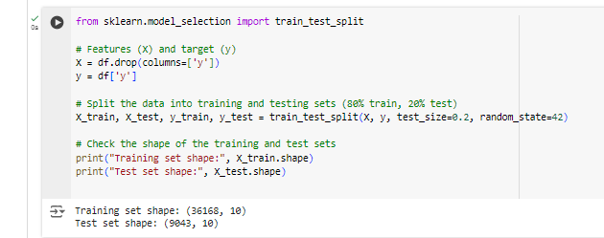
Figure 19: Python Code: Splitting the Dataset into Training and Testing Sets
In this step, categorical features, including job, marital, and education_qual, might have to be feature-engineered for splitting, as most machine learning models process numeric inputs.
- Step 2: Feature Encoding with LabelEncoder. Label encoding is a transformation where features with nominal data types are transformed into integer types by replacing all features with different numbers (Bolikulov et al., 2024). Since the dataset contains categorical features, such as job, marital, and education qualifications, the features will need to be encoded to train the models. LabelEncoder from sklearn has been utilized to transform each categorical predictor into numerics.
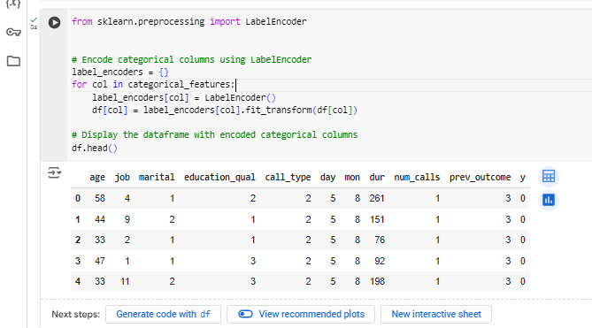
Figure 20: Python Code: Encoding Categorical Columns Using LabelEncoder
From the figure 21 we can see that, LabelEncoder assigns a numeric value as a label to each category in a specific column. For instance, assuming the job column contains the values management, technician, and blue-collar, the labels will be 0, 1, and 2. The dictionary label_encoders store a LabelEncoder object for each column so that the encoding can be decoded later if needed. Hence, by applying LabelEncoder, the output dataset is converted into numeric form to fit machine learning models that only accept numerical inputs.
- Step 3: Scaling the Data. The features may eventually need to be scaled, especially for specific algorithms like logistic regression or K-Nearest Neighbor (KNN) (Ahsan et al., 2021). Standardization is one of the most commonly used techniques where the values are adjusted for every feature such that its value has zero mean and unit variance.
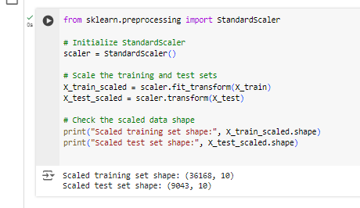
Figure 21: Python Code: Standardizing the Dataset
Once the data has been split and encoded, the models will be ready to train on the processed dataset.

Summary of Steps
In model selection, some of the algorithms relevant to binary classification were considered. Thus, the Decision Tree, Random Forest, and, at last, the Logistics Regression algorithm was selected for further investigation. In this work, data splitting was done to the extent of 80/20 to arrive at the training set of data points as well as the test set of data points. The categorical features were concretized by means of one hot encoder, and the necessary scaling was performed.
These preparations steps guarantee that the models shall go through properly formatted and separated dataset which forms the basis to the subsequent process of training and evaluating the models on the dataset in question.

TASK 3: MODEL INTERPRETATION AND EVALUATION

Model Interpretation
Interpretability in machine learning is the process by which the trained model can be explained based on its decision-making, which is the essential feature for the particular decision (Mi, and Zhou, 2020). For this task, the following steps will be performed:
- Train the Primary Model (Decision Tree)
- Evaluate and Compare Alternative Models (Logistic Regression and Random Forest)
- Feature Importance Analysis
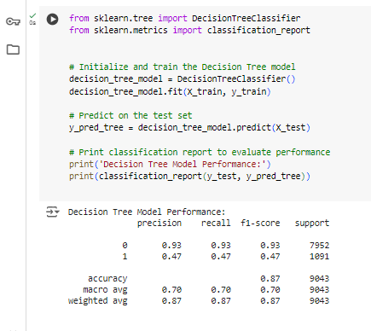
Figure 22: Python Code: Training and Evaluating the Decision Tree Model

Decision Tree Model Interpretation
The Decision Tree model is assessed concerning its capacity to categorize an instance into the given target classes. The model's performance metrics are as follows:
- Accuracy: 0.8712
- Precision: 0.4667
- Recall: 0.4748
- F1 Score: 0.4707
Key Insights:
- Accuracy: It accurately classifies approximately 87.12% of the instances, showing high overall correctness.
- Precision: The precision of the model for the positive class (conversion) is 46.67%, which is the amount by which the model accurately identified a positive instance among the total number of predicted positives.
- Recall: The recall for the positive class is 47.48%, meaning the model can control 47.48% of the actual positive cases.
- F1 Score: This means that the model achieved a 47.07% F1 score, which shows that the model has both precision and recall rates. The Decision Tree exhibits satisfactory results, underscoring a rather good accuracy of the positive cases, but it may be fine-tuned.
Feature Importance from Decision Tree
The Decision Tree model also showed feature importance, where the model identified which features contributed most to arriving at the decision. The following table below gives an overview of the feature importance values.
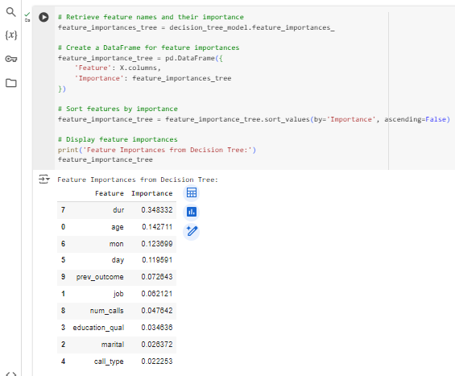
Figure 23: Python Code: Feature Importance from Decision Tree
Table 1: Feature Importance from Decision Tree Model
Feature | Importance
Duration (dur) | 0.3483
Age | 0.1427
Month(mon) | 0.1237
Day | 0.1196
Previous Outcome | 0.0726
job | 0.0621
Number of calls | 0.0476
Education Level | 0.0346
Marital Status | 0.0264
Call type | 0.0223

Key Insights:
The length of a call proves most pivotal in the likelihood of each caller’s conversion, with age and month as the following relevant predictors. Other variables such as job, education level and marital status as well as others also affect the model predictions’ but to a lesser extent.

Logistic Regression Interpretation
Logistic regression is one of the familiar classifiers from the area of bi-secondary classification task where the primary target is to estimate the probability of the input to be of the particular class or not (for instance, whether the customer will purchase a product or not). It works because it maps the input features and the log-odds of the output class.

3.1.2.1 Key Characteristics
- Linear Model: Logistic regression estimates the coefficients in such a way that it models the dependent variable with the usage of the logistic function of the function of independent variables.
- Interpretability: High interpretability is another advantage since one can easily explain the outcome of the coefficients in relationship with the odds ratio of the input variables on the target dependent variable.
- Probability Estimation: Logistic regression offers a probability score between 0 and 1 for each class making it applicable where we want a probability interpretation of the results.

Performance Metrics:
The Logistic Regression model provides a different perspective on classification performance:
- Accuracy: The logistic regression model had a favorable level of accuracy as a baseline model – 88.72%.
- Precision: It shows that knowledge of true positives from all positive predictions is reasonable and it makes 59.78 percent of correct decisions.
- Recall: The recall score of 19. 89% represents its low capability of identifying all actual positive data, especially important in sensitive problem domains.
- F1-Score: The average of precision and recall is given by the F1-score (29.85%) although the low value of recall that it contains.

Strengths:
- It is less complex to use and analyze than other models of its nature.
- Is effective when one has linear relationship between inputs and the target variable.
- Returns variability of outputs and hence can be used in determining the level of certainty of predictions.
Limitations:
- Although logistic regression model can be a powerful tool in analyzing data, it is constrained by a few factors including underestimations of non-linearity between the input features and the log-odds.
- It may underperform when the characteristics of the data are nonlinear or when the features are interactive in the relationship.
Table 2: Feature Importance in Logistic Regression Model
Feature | Importance | Absolute Coefficient
Duration (dur) | 1.426167 | 1.426167
Call Type | -0.704964 | 0.704964
Marital | 0.253843 | 0.253843
Education Level | 0.248462 | 0.248462
Age | 0.147580 | 0.147580
Previous Outcome | -0.131582 | 0.131582
Number of calls | -0.074169 | 0.074169
Day | -0.068371 | 0.068371
Job | 0.026071 | 0.026071
Month (mon) | 0.017738 | 0.017738

Key Insights:
The classification of Logistic Regression is 88.72% in general, and the precision of the positive class is 59.78%. Nevertheless, it has a recall of only 19.89%, meaning it gets many of the actual positive cases wrong. This results in an F1 score of 29.85%, which means that the model was not as powerful in identifying positive cases as it was in other cases, and there is a compromise between precision and recall.
In conclusion, there is no question that logistic regression is one of the most valuable because of the ease with which it can be applied and understood. However, its performance is moderate especially on cases where the data relationships are complex hence a low recall when applied in the project.

Random Forest Interpretation
The Random Forest model provides a robust performance metric:
- Accuracy: 0.9040
- Precision: 0.6509
- Recall: 0.4409
- F1 Score: 0.5257
Key Insights:
The findings reveal that the Random Forest model is superior to all the classification models with a high accuracy of 90.40%, precision of 65.09% and recall of 44.09% for the positive examples. This is seen in the fact that its F1 score stands at 52.57%, which shows high accuracy in the balance between Precision and Recall, thus suitable for classification as compared to the other metrics.

Model Evaluation
The evaluation metrics for each model are summarized in the table below, providing a clear comparison of performance:
Table 3: Model Evaluation of Decision Tree, Logistic Regression and Random Forest Models
Model | Accuracy | Precision | Recall | F1-Score
Decision Tree | 0.8712 | 0.4667 | 0.4748 | 0.4707
Logistic Regression | 0.8872 | 0.5978 | 0.1989 | 0.2985
Random Forest | 0.9040 | 0.6509 | 0.4409 | 0.5257

- Decision Tree: That said, the model gives reasonable accuracy and feature importance, which can be a downside to its lower precisions and recalls, particularly for the positive class, making it perhaps not the most suited model for high-risk classification.
- Logistic Regression: Very accurate and precise, but only identifies a few true positives and, therefore, has low recall.
- Random Forest: A type that demonstrates excellent performance in terms of accuracy, precision, and recovery balance of recall. It is the most accurate model for forecasting conversion of the three models.
The proposed approach is based on the Random Forest model, which performs the best on all metrics. An even higher improvement in the results could be achieved through additional tuning and validation of the model.

CONCLUDING REMARKS

Summary of Findings
Three classification models, Decision Tree, Logistic Regression, and Random Forest, were used to make customer conversion predictions (Kiguchi, Saeed, and Medi, 2022) for HashSysTech Insurance. The Decision Tree model yielded fair accuracy in terms of both precision and recall, and the best predictor was the call duration. Logistic regression yielded 88.72% accuracy and 59.78% precision, and there was relatively low recall, but positive case identification was also low. Random Forest had the highest accuracy of 90.40% while having a low precision of 65.09% and recall of 44.09% compared to the other models.

Business Implications for HashSysTech Insurance
The results of the model evaluations provide significant implications for HashSysTech Insurance's marketing strategies and decision-making processes:
- Targeted Marketing Efforts: Customer conversion can be improved using the Random Forest model because it predicts better than the marketing campaign of the other two model campaigns, which target people with a high chance of being converted with the help of HashSysTech Insurance.
- Efficient Use of Resources: This means that marketing costs can be efficiently managed by focusing on high-value/ potential leads and avoiding or minimizing spending on low-value/potential leads. Hence, the chances of conversion and overall ROI are enhanced.
- Strategic Insights: The Decision Tree model helps understand how customers respond to HashSysTech Insurance engagement, such as call duration.
- Ongoing Optimization: It is recommended that HashSysTech Insurance incorporate the workflows into the models and continuously update them to meet the ever-changing customers’ behaviors and markets.
Therefore, interpreting outcomes obtained from the Random Forest model and integrating these outcomes into the company’s marketing strategies (Aria, Cuccurullo, and Gnasso, 2021) will enable HashSysTech Insurance to make better decisions about resource allocation and enhance the company’s performance.

BIBLIOGRAPHY

Lester, J.N., Cho, Y. and Lochmiller, C.R., 2020. Learning to do qualitative data analysis: A starting point. Human resource development review, 19(1), pp.94-106. DOI: https://doi.org/10.1177/1534484320903890
Cai, S., Zhou, J. and Pan, J., 2021. Estimating the sample mean and standard deviation from order statistics and sample size in meta-analysis. Statistical methods in medical research, 30(12), pp.2701-2719. https://doi.org/10.1177/09622802211047348
Hancock, J.T. and Khoshgoftaar, T.M., 2020. Survey on categorical data for neural networks. Journal of big data, 7(1), p.28. Retrievd from https://link.springer.com/article/10.1186/s40537-020-00305-w
Lububu, S. and Kabaso, B., 2023, December. Reflections on Feature Engineering and Design Using Causal Machine Learning (CML) for African Swine Fever (ASF) Diagnosis. In International Conference on Artificial Intelligence and its Applications (pp. 21-31). https://doi.org/10.59200/ICARTI.2023.004
Joel, L.O., Doorsamy, W. and Paul, B.S., 2022. A review of missing data handling techniques for machine learning. International Journal of Innovative Technology and Interdisciplinary Sciences, 5(3), pp.971-1005. https://doi.org/10.15157/IJITIS.2022.5.3.971-1005
Enders, C.K., 2022. Applied missing data analysis. Guilford Publications. Retrieved from https://books.google.co.ke/books?hl=en&lr=&id=uHt4EAAAQBAJ&oi=fnd&pg=PP1&dq=Enders,+C.K.,+2022.+Applied+missing+data+analysis.+Guilford+Publications.&ots=W0uNQ5nzXa&sig=3e9bPuJrlsURADSodRV-AXp7bVo&redir_esc=y#v=onepage&q=Enders%2C%20C.K.%2C%202022.%20Applied%20missing%20data%20analysis.%20Guilford%20Publications.&f=false
Smiti, A., 2020. A critical overview of outlier detection methods. Computer Science Review, 38, p.100306. https://doi.org/10.1016/j.cosrev.2020.100306
Javed, U., Ijaz, K., Jawad, M., Ansari, E.A., Shabbir, N., Kütt, L. and Husev, O., 2021. Exploratory data analysis based short-term electrical load forecasting: A comprehensive analysis. Energies, 14(17), p.5510. https://doi.org/10.3390/en14175510
Injadat, M., Moubayed, A., Nassif, A.B. and Shami, A., 2020. Systematic ensemble model selection approach for educational data mining. Knowledge-Based Systems, 200, p.105992. https://doi.org/10.1016/j.knosys.2020.105992
Nguyen, Q.H., Ly, H.B., Ho, L.S., Al-Ansari, N., Le, H.V., Tran, V.Q., Prakash, I. and Pham, B.T., 2021. Influence of data splitting on performance of machine learning models in prediction of shear strength of soil. Mathematical Problems in Engineering, 2021(1), p.4832864. https://doi.org/10.1155/2021/4832864
Bolikulov, F., Nasimov, R., Rashidov, A., Akhmedov, F. and Young-Im, C., 2024. Effective Methods of Categorical Data Encoding for Artificial Intelligence Algorithms. Mathematics, 12(16), p.2553. DOI: 10.3390/math12162553
Ahsan, M.M., Mahmud, M.P., Saha, P.K., Gupta, K.D. and Siddique, Z., 2021. Effect of data scaling methods on machine learning algorithms and model performance. Technologies, 9(3), p.52. https://doi.org/10.3390/technologies9030052
Mi, J.X., Li, A.D. and Zhou, L.F., 2020. Review study of interpretation methods for future interpretable machine learning. IEEE Access, 8, pp.191969-191985. https://doi.org/10.1109/ACCESS.2020.3032756
Kiguchi, M., Saeed, W. and Medi, I., 2022. Churn prediction in digital game-based learning using data mining techniques: Logistic regression, decision tree, and random forest. Applied Soft Computing, 118, p.108491. https://doi.org/10.1016/j.asoc.2022.108491
Aria, M., Cuccurullo, C. and Gnasso, A., 2021. A comparison among interpretative proposals for Random Forests. Machine Learning with Applications, 6, p.100094. https://doi.org/10.1016/j.mlwa.2021.100094

APPENDIX

Code Implementation
The code used for data exploration, preparation, model training, and evaluation is available in the following Google Colab notebook:
Google Colab Code Implementation
This notebook includes:
- Data Exploration and Preparation: This is about filling in missing values, creating new numerical features from categorical ones, and making initial impressions of the data.
- Model Selection and Training: Data division and training of components of Decision Tree, Logistic Regression, and Random Forests.
- Model Interpretation and Evaluation: An assessment of the performance of the built models, such as accuracy, precision-recall, and, F1 score, feature importance.
The notebook can be used to consult and get a general perspective on how the code and approaches used in the project have been developed.

